American Heart Association - Affiliate Sponsorship Agreement 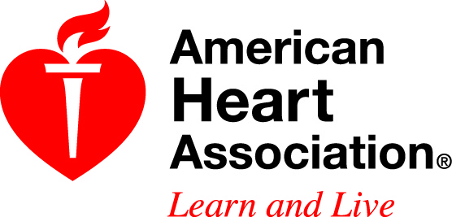
Sponsor Name: ___________________________________________
Sponsor’s Contribution Amount: $Click here to enter text.
In-Kind Goods/Services or Publicity/Media: as listed on the proposal
AHA Cause and/or Event(s): 2013 Champaign Go Red for Women Luncheon
Location of AHA Activity/Event(s): Hilton Garden Inn, Champaign
Date(s) of AHA Activity/Event(s): 2/28/2013
Term of Agreement: Start: 2/28/2013 End: 2/28/2013 (not to exceed 1 days)
Contribution Payment /Due Date: Invoice to be paid according to the dates specified below. (If multiple payments, list each payment date and amount separately.)

Due Date (must be at least 30 days prior to event) Amount Due on Due Date
1. Enter a date. $___________________
2. Enter a date. $___________________
3. __________ $___________________
4. __________ $___________________
(to be completed prior to signature by sponsor)
Send Payment to: American Heart Association
Midwest Affiliate – Accts Rec
PO Box 4002902
Des Moines, IA 50340-2902
Check should be made payable to the American Heart Association.

Purpose: The purpose of this sponsorship is to benefit the American Heart Association (“AHA”) and advance its not-for-profit mission of building healthier lives, free from cardiovascular diseases and stroke. Sponsor would like to assist the AHA to carry out its mission and agrees to provide the support outlined above. Sponsor understands that as a not-for-profit charitable organization AHA cannot promote or endorse Sponsor’s products or services.

- Sponsor agrees that as a not-for-profit charitable organization, the AHA will be required to disclose its sources of funding, including Sponsor’s funding or other resources provided under this Agreement.
- No rights to use AHA servicemarks are granted in this Agreement.
- In appreciation of Sponsor’s support, AHA will recognize Sponsor’s donation in the appropriate AHA Cause or Event materials. Sponsor grants permission to AHA to display Sponsor’s name and trademark for the Term of this Agreement, with Sponsor’s prior review and approval. (See details of Sponsor recognition and benefits on the attached form.)
- Sponsor and AHA agree that each is responsible for its own business activities and for its action or inaction relating to the specific Cause or Event activities under this Agreement. Sponsor will be responsible for securing any necessary release forms from participants in any Sponsor activity held at AHA’s Cause or Event activity.
Sponsor Contact Information: Sponsor Billing Information:
Name Title Click here. | Name same Title
Company Name | Company Name
Address | Address
City Click here. State IL (Illiinois) Zip | City State Choose. Zip
Phone Click here. Fax | Phone Fax
Email Click here to enter text. | Email
My signature indicates authorization to make this commitment on behalf of my company.
Signature (Must be signed)________________________________ Date (Must be dated) ______________________
Thank you for your support of the American Heart Association

FOR AHA USE ONLY:
AHA Staff Signature: ______________________________________________
AHA Staff Supervisor Signature: ____________________________________
Please send this completed form along with a completed transmittal sheet and all required supporting documents to your local finance contact.

